Reading at Leen Mills Primary School – Intent
The aim of our reading curriculum at Leen Mills Primary School is:
- all children enjoy and learn to read as quickly as possible by developing our children’s phonetic skills which leads to them reading accurately, fluently, confidently and frequently;
- children are inquisitive and question texts to deepen their understanding of what they have read so they develop a true love of reading;
- to provide broad and balanced reading opportunities so children experience an increasingly diverse and varied range of books throughout our curriculum open doors to social diversity, broadening children’s experience of different cultures and experiences and understanding a character’s point of view. Our children leave us as respectful citizens with the confidence to discuss what makes all of us unique, valued and respected in terms of culture, race, ethnicity, gender, education, disability, identity, nationality, religion, sexuality, neurodiversity, social background, and beliefs;
- to enrich children’s vocabulary through high quality texts; they explore and discuss mature themes and make connections with the wider world. Our children are empowered to develop communication skills for education and for working with others: in school and beyond;
- children have a strong command of the spoken and written word, and a love of literature through widespread reading for pleasure;
- to inspire and raise aspiration we are determined that every child will learn to read, regardless of their background, needs or abilities. The teaching of reading is prioritised to ensure that our children read widely and develop fluency, confidence, and enjoyment of reading.
We are determined that:
- Every child will learn to read, regardless of their background, needs or abilities.
- All children, including the weakest readers, make sufficient progress to meet or exceed age-related expectations.
- Children will be familiar with, and enjoy listening to a wide range of stories, poems, rhymes and non-fiction.
- Children acquire a wide vocabulary and develop language comprehension, as we nurture a love of reading through stories, poems, rhymes and non-fiction.
- Children develop the habit of reading widely and often, for both pleasure and information.
We have developed a Reading curriculum that is:
- ambitious for all pupils;
- coherently planned and sequenced around progressive reading objectives that is broad and balanced for all pupils;
- successfully adapted, designed and developed for pupils with special educational needs.

Reading at Leen Mills Primary School – Implementation
We follow the Read Write Inc programme from F1 to Year 2. Read Write Inc lessons take place first thing in the morning across the Early Years and Key Stage 1 classes. The Read Write Inc philosophies are embedded in the teaching and learning of reading and writing throughout the curriculum. The use of this synthetic phonics programme ensures that all children are taught:
- phonemic awareness (the sounds that make up words such as c/a/t);
- the sound–spelling relationships in words; - how to say the sounds that make up words; and to do this by:
- using texts that are made up of words that use the sound–spelling relationships children have learned; - using interesting and authentic stories to develop vocabulary and language comprehension.
Children are assessed regularly and placed in groups according to their assessment. This ongoing assessment of pupils’ phonics progress is sufficiently frequent and detailed to identify any pupil who is falling behind the programme’s pace. If they do fall behind, targeted support is given immediately. The school has clear expectations of pupils’ phonics progress term-by-term, from FS2 to Year 2, through the use of a phonics tracker which is updated half-termly.
Children whose reading is below expectations for their age, including those with special educational needs or with English as an Additional Language, receive fast track 1:1 tutoring. School leaders, the SENDCO and teaching staff work together to make sure all of these pupils make rapid progress.

In KS2 we implement:
- A reading curriculum based on high quality texts, across a wide range of genres that show progression throughout the years;
- imaginative and creative planning to ignite children’s passion for reading through a range of lesson styles including; drama, role play and classroom discussion;
- A systematic, synthetic phonics programme Read, Write, Inc for those children that have been identified with gaps in their phonics;
- Children are taught strategies to help them read (e.g. background knowledge, visualisation, questions predict and I wonder, breakdown and repair, inference, vocabulary and build the gist);
- Regular ERIC sessions where children have the opportunity to widen their experience of reading alongside their peers. All children have access to the same book, vocabulary and discussion throughout these carefully planned lessons to enrich their reading experience;
- Clearly identified ‘ERIC Tasks’ to provide children with the opportunity to use book journaling ideas to practise responding to a text;
- Reciprocal reading sessions to teach children the techniques to clarify, predict, question and summarise a short section of text;
- Cross-curriculum reading opportunities that deepen children’s topic knowledge;
- Language rich reading environments where every child reads in class every day;
- Clear expectations that children read at home at least three times a week and record this in their reading diaries to progress through the reading trophies to 250+ for a reward during the Summer Term for being a regular reader.

Reading at Leen Mills Primary School – Impact
The impact of this in school is:
- Enthusiastic readers who are confident to take risks in their reading, and love to discuss and share their thoughts;
- Children are successful academically and able to thrive in all curriculum areas.

Expectations of Progress against book bands
The sequence of reading books shows a cumulative progression in phonics knowledge that is matched to the school’s phonics programme. Teachers prioritise the sufficient practice in reading and re-reading books that match the grapheme-phoneme correspondences they know, both at school and at home. The use of book banded books is used in KS2 to ensure all children have access to a range of books and can develop the wider skills of reading following integrated reading objectives which cover the depth and breadth of teaching and learning required. Children continue on this system until they become fluent readers and are secure at cream level book band.
Home reading is strongly encouraged at least three times per week and families are asked to record this in reading diaries. Each class has a reading display with reading trophies and certificates are awarded to celebrate frequent reading.

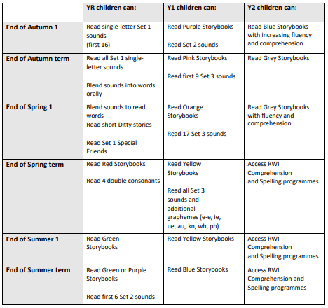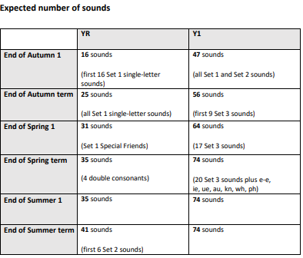
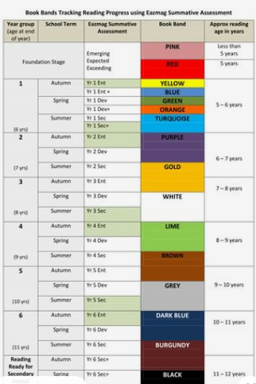

Reading for pleasure
Leen Mills Primary School is committed to enriching its practice, making stronger links with parents around reading and ensuring all staff are well positioned to nurture life-long readers. To support this, we host a number of varied events throughout the year to promote reading for pleasure and increase our reading communities. The Reading lead along with the Reading Rangers (a dedicated creative curriculum group) participated in the Hucknall Teachers Readers Group led by the research of the OU/UKLA project which has examined children’s and teachers’ reading lives, and established effective ways to support Reading for Pleasure. The Reading Lead published a project titled ‘Reading Rangers Enriches’ which celebrated the events Leen Mills hosted to promote reading for pleasure and encourage a wider reading community - such as Book Cafes, Nottinghamshire Look for a Book and a BookFest.

Dedicated time for reading aloud to children is prioritised throughout the day, following a progression of recommended key texts in addition to texts chosen by either the children or teachers from class collections, including those that are more recent and topic related from the Education Library Service. This Class Reader time is made more special with additional soft lighting in each classroom to create at atmosphere for enjoyable reading.

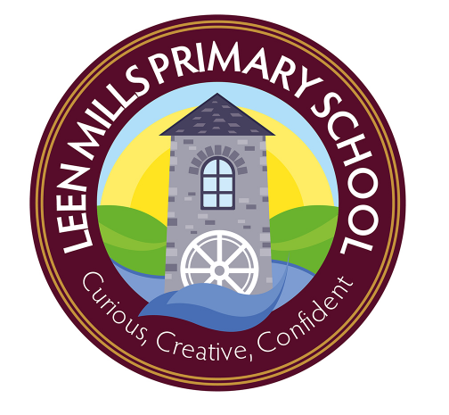
Leen Mills Primary School - Framework for Reading
 | EYFS | KS1 | KS2
Pedagogical Approach and Strategies | RWI phonics streamed lessons involve the teaching of a new sound, decoding and blending words and eventually moving on to reading short story books.  Children will:  learn 44 sounds and the corresponding letters/letter groups using simple picture prompts – see below  learn to read words using Fred talk and sound blending  read from a range of storybooks and non-fictions books matched to their phonic knowledge  work well with partners  develop comprehension skills in stories by answering ‘Find It’ and ‘Prove It’ discussion questions  Selected children (lowest 20%) will receive extra pinny time activities to boost their phonics and 1:1 (5 minute focused sessions) to target gaps in knowledge  Class read to by adult daily during milk and fruit time. | RWI phonics streamed lessons  Children will be introduced to ‘Ditty Books’ when they successfully begin to read single words. Pure phonics should be used for all the sounds taught.  Children use sound-blending (Fred Talk) when decoding texts. They will bring the text home once they have read and discussed the book in class.  Within all the books, children will have red and green words to learn to help them to become speedy readers. Red words are words that are not easily decodable and challenge words to extend their vocabulary. Green words are linked to the sounds they have been learning and are easily decodable.  Dots are used under the single letter sounds and dashes are used under special friends.  During the RWI sessions, children will read the book three times, this is to ensure that children become overly familiar with the text and become fluent and speedy readers! At each new reading stage, they will have plenty of opportunities to improve their developing comprehension skills.  Selected children get 1:1 catch up sessions (5 minute focused sessions) to target gaps in knowledge.  Class read to by adult daily during milk and fruit time. Children vote on which book they get to hear. | ERIC (Everyone Reading In Class) as a whole class ch read a planned text.  Ch read with a partner matched to support their reading ability.  ERIC sessions are structured with a Reciprocal Reading style approach to clarify, predict, question and summarise. These are arranged as:  -shared vocabulary definitions  -reading a section with a partner  - answering a range of questions focused on that section  -three way differentiated post-read task completed in learning journals to demonstrate the learning objective met.  The post-read tasks are book journal ideas to demonstrate that ch have achieved a range of learning objectives.  Daily Class reader is read to the class by an adult (usually at the end of the day) with twinkle (subtle) lighting. Adults model expression, focus on new vocabulary, express their opinion and model their thinking about a small section of the book.  Ch are encouraged to read in all subjects including foundation subjects from texts, on the screen.  Discreet comprehension sessions are taught based on sat’s style questions.  Reading for Pleasure is encouraged with four trolleys full of blankets and cushions that are used both in the class and outside (weather dependent).
Phonics | Read Write Inc – a systematic, synthetic phonics programme is consistently followed and taught (4 times a week) in Foundation, KS1 and selected lowest 20% KS2.  All phonics sessions are well structured, active, engaging and well matched to children’s phonics ability. |  | Spelling is taught three times a week in KS2 and ch are taught how to add the phoneme dots and dashes and count the syllables in a word.  Ch are reminded to use decoding to break down unfamiliar words  Small streamed target phonics session for identified children in year 3/4/5 that are working well below expected level based on their gaps in phonics.
Language | Consistent language and gestures for Read Write Inc across the school.  Partner discussions are well established in the ‘no hands-up’ environment. Ch discuss questions with a partner and know that they could be selected at any time to feedback.  Explicit weekly teaching of vocabulary through adult led tasks begin in Foundation with key links to core quality texts and continue through school. The children are assessed on entry into the Foundation Stage and those identified as needing language support take part in NELI (Nuffield Early Language Intervention) four times a week.
 | The EYFS environment is language rich; with a wealth of opportunities to talk, listen and build narratives.  All EYFS adults support and extend language well through play. | Consistent language for ERIC sessions and Reciprocal reading terms in KS2 – clarify, predict, question and summarise. The type of question is explicitly taught – Retrieval, Inference, Prediction, Sequencing and Choice.  Book Talk sentence stems help children frame their responses and bonus talk words help extend children’s ability to talk about their reading.  Working Wall displays shared vocabulary and new vocabulary.
Environment | Each class has a consistent phonics display with speed sound charts and resources or an English working wall to demonstrate modelled writing, vocabulary collection and taught spellings.  Every classroom has a learning journey wall that displays the children’s work and topic tasters changed half termly.  Topic Tasters Posters feature key language and topic related questions, these are also displayed in central corridor and shared on class dojo to inform parents on upcoming learning.  Inspire library service books are ordered half termly to support topics with additional modern fiction too.
 | Reading in the environment in unit and in outdoor learning area – labels, instruction, children’s writing, appropriate books in imaginative play area  Big books available to share in reading area  Rotate books in reading area. | Each class has high quality texts in book corner.  Range of genres in reading area in each class. | ERIC texts kept in the class and extra copies in the library for pleasure.  Each class have a range of genres in their book corners.  First News – current affairs newspaper for children to access in the library.
Assessment | There are Read Write Inc Sound Assessments each half term, these record the number of sounds the children know and used to track progress through taught sounds. This informs the grouping and book bands of children alongside an expected progression grid to enhance their developing knowledge of phonics.  New grouping takes place each half term, with the additional flexibility that some children may change groups depending on their need. |  | Children progress and are tracked through the colour book band against observations of reading behaviours and achieving reading objectives.  Benchmarking for children before moving book bands and at the beginning of each year which includes a running record for fluency and comprehension questions to ensure ch are rounded readers.  Regular termly assessments to futher enhance teacher judgements of ch’s reading ability and inform interventions and future teaching.  Rising Stars NTS Assessment termly and SATs papers Y6
Timetabling | Read, Write, Inc sessions 4 times a week  1:1 reading once a week  Regular Readers 2-3 times a week | Read, Write, Inc sessions 4 times a week  1:1 reading once a week  Regular Readers 2-3 times a week | ERIC activities at least 20 mins x 3 a week  Class Reader at least 10 mins daily  Reading for Pleasure – ad hoc  Topic linked reading opportunities using the reading strategies taught
EAL provision | Ch to be assessed and EAL team contacted. TA support immediately as required.
Interventions  inc SEN provision | Daily story-time with an adult  Foundation Lead- ELKLAN and NELI trained. NELI groups  RWI 1:1 keep up sessions  Regular reading sessions including PP children. | RWI 1:1 keep-up sessions  Regular 1:1 reading sessions for SEN and PP children | Specific targeted Read Write Inc streamed KS2 interventions (Mon-Thurs) for ch that did not pass the phonics screening and with key gaps in phonics (including PP children and lowest 20%)  Switch-on Reading for children working well below expected standard  Inference Intervention for groups of children working below expected standard in comprehension in KS2 – assessment and teacher informed  TA’s deliver speed reading interventions in year 5 and 6 to increase fluency  Regular 1:1 reading sessions for SEN, PP, ch that do not read at home and lowest 20%.
Staff CPD  & induction | RWI teaching portal to access training videos  RWI weekly phonics meetings to share information and best practice  RWI coaching sessions one morning a week to support staff along with buddy system  Staff meetings as needed to disseminate training, practice and updates from the network  KS meetings to set expectations, share ideas and feedback impact of practice
Reading Community | Each child takes home a RWI book band text, a book bag book and a bedtime book once they reach Red Ditty books. Prior to that they take home a sound blend book or a photocopiable masters text.  Whole School – Stay and Read Sessions twice a term to invite parents in to read with their child  Parent RWI information meeting plus a video of the sound taught in the RWI session.  Class Dojo – use of reward points for frequent readers, certificates and photos for Whole School incentives  Leen Mills Reading Rewards Trophies – certificates and assembly celebrations.  Termly reading additional events - World Book Day, sponsored read, trips to the library, Author visits, Inspire library van visit to school |  | 2 x home readers changed once a week (1 colour book band book and 1 Reading for Pleasure). Extra decodable book for ch reading below expected colour book band.  Reading diaries checked once a week with a running tally kept in the book.  Reading Rewards trophies on display in the classroom with ch’s names/photos and certificates awarded to show the ch’s progression.  Photos of children on class dojo when they receive their reading certificates.  Reading Rewards Treat towards the end of Summer Term to celebrate children that have read 250+ times.  Twice termly whole school stay and read sessions with parents invited in to read with their child.
ERIC (Everyone Reading In Class) overview
Year | Autumn Term |  | Spring |  | Summer
 | 1 | 2 | 1 | 2 | 1 | 2
Year 3 | Esio Trot – Roald Dahl  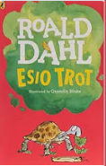 | Esio Trot – Roald Dahl | The Boy Who Grew Dragons – Andy Shepherd  A Walk In Paris  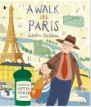 | The Boy Who Grew Dragons – Andy Shepherd  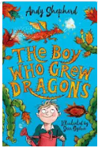 | Egyptian Myths and a range of non-fiction texts  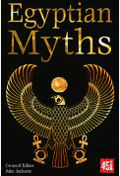 | Egyptian Myths and a range of non-fiction texts
Year 4 | Inference techniques using various short extracts | Voices in the Park by Anthony Browne  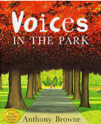 | A range of non-fiction texts. | A range of non-fiction texts. | Charlottes Web by E.B White  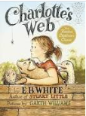 | Charlottes Web by E.B White
Year 5 | The Explorer - Katherine Rundell  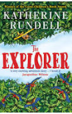 | Wonder - RJ  Palacio  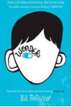 | Wonder – RJ Palacio  Arsenic for Tea – Robin Stevens | Arsenic for Tea – Robin Stevens  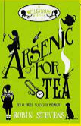 | The Wild West -  Henry Brook | Who Let the Gods out? - Maz Evans  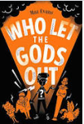
Year 6 | Short extracts Poems Stories Non-fiction | Short extracts Poems Stories Non-fiction | Short extracts Poems Stories Non-fiction | Short extracts Poems Stories Non-fiction | Holes  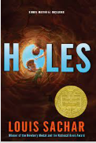 | Once  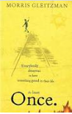

Leen Mills Reading Skills Progression
 | EYFS  30–50 40 – 60 m  EarlyLearningGoals | Year 1 | Year 2 | Year 3 | Year 4 | Year 5 | Year 6
Phonics and Decoding | + show an awareness of rhyme, rhythm and alliteration.  + continue a rhyming string.  + hear and say initial sound in words.  + segment the sounds in simple words and blend them together.  + link sounds to letters, naming and sounding the letters of the alphabet.  + use phonic knowledge to decode regular words and read accurately.  + read some common irregular words. | + apply phonic knowledge to decode words.  + blend sounds in unfamiliar words using GPCs taught.  + respond speedily, giving correct sound to graphemes for all 40+ phonemes.  + read words containing -s, -es, -ing, -ed and -est endings.  + read words with apostrophes for contractions.  + read aloud phonically-decodable texts.  + read Y1 common exception words, noting unusual correspondences between spelling and sound and where these occur in words. | + secure phonic decoding until reading is fluent.  + read accurately by blending the graphemes taught, recognising alternative sounds for graphemes.  + accurately read most words of two or more syllables.  + read most words containing common suffixes.  + read most words quickly and accurately without overt sounding and blending.  + read most Y1 and Y2 common exception words, noting unusual correspondences between spelling and sound and where these occur in the word. | + apply their growing knowledge of root words, prefixes, including: in-, im-, il-, ir-, dis-, mis-, un-, re-, sub-, inter-, super-, anti- and auto- and suffixes, including: -ation, -ly, -ous, -ture, -sure, -sion, -tion, -ssion and –cian.  + begin to read aloud and to understand the meaning of new words they meet.  + read further exception words, noting the unusual correspondences between spelling and sound, and where these occur in the word.  + begin to read Y3/Y4 exception words. | + read most words fluently and attempt to decode any unfamiliar words with increasing speed and skill.  + apply their knowledge of root words, prefixes and suffixes/word endings to read aloud fluently.  + read all Y3/Y4 exception words, discussing the unusual correspondences between spelling and where these occur in the word. | + read most words fluently and attempt to decode any unfamiliar words with increasing speed and skill, recognising their meaning through contextual cues.  + apply their growing knowledge of root words, prefixes and suffixes, including: -sion, -tion, -cial, -tial, -ant/-ance/-ancy, -ent/- ence/-ency, -able/-ably and -ible/ibly, (morphology and etymology) to read aloud fluently and understand the meaning of new words they meet.  + read most Y5/ Y6 exception words, discussing the unusual correspondences between spelling and sound and where these occur in the word. | + read fluently with full knowledge of all Y5/ Y6 exception words, root words, prefixes, suffixes (morphology and etymology) and to decode any unfamiliar words with increasing speed and skill, recognising their meaning through contextual cues.
Fluency | + show interest in illustrations and print in books and the environment.  + recognise familiar words and signs.  + look and handle books independently.  + know that print carries meaning and is read from left to right and top to bottom.  + ascribe meanings to marks that they see in different places.  + begin to break the flow of speech into words.  + begin to read words and simple sentences.  + understand humour.  + read and understand simple sentences. | + accurately read texts consistent with their developing phonic knowledge.  + reread texts to build up fluency and confidence in word reading.  + check that a text makes sense to them as they read and to self- correct. | + read aloud books (closely matched to their improving phonics), sounding out unfamiliar words accurately, automatically and without undue hesitation.  + reread these books to build up fluency and confidence in word reading.  + read words accurately and fluently without overt sounding and blending.  + show understanding by drawing on what they already know or on background information and vocabulary.  + check that the text makes sense to them as they read and to correct inaccurate reading. | In Key Stage 2, teaching comprehension skills takes precedence over teaching word reading and fluency specifically for the majority of children. When teaching is focused on word reading this is to support the development of vocabulary and speed, e.g. at over 90 words per minute, in age-appropriate texts.
Book Talk | + listen to stories with increasing attention and recall.  + begin to be aware of the way stories are structured.  + describe main story settings, events and principal characters.  + enjoy an increasing range of books.  + follow a story without pictures or props.  + listen to stories, accurately anticipating key events and respond to what they hear with relevant comments, questions or actions.  + demonstrate understanding when talking with others about what they have read. | + listen to and discuss a wide range of fiction, non-fiction and poetry at a level beyond that at which they can read independently.  + link what they have read or have read to them to their own experiences.  + retell familiar stories in increasing detail.  + join in with discussions about a text, taking turns and listening to what others say.  + discuss the significance of titles and events. | + participate in discussion about books, poems and other works that are read to them and those that they can read for themselves, explaining their understanding and expressing their views.  + become increasingly familiar with and to retell a wide range of stories, fairy stories and traditional tales.  + discuss the sequence of events in books and how items of information are related.  + recognise simple recurring literary language in stories and poetry.  + ask and answer questions about a text.  + make links between the text they are reading and other texts they have read. | + recognise, listen to and discuss a wide range of fiction, poetry, plays, non-fiction and reference books or textbooks.  + use appropriate terminology when discussing texts - plot, character and setting. | + discuss and compare texts from a wide variety of genres and writers.  + read for a range of purposes.  + identify themes and conventions in a wide range of books.  + refer to authorial style, overall themes and features.  + identify how language, structure and presentation contribute to meaning.  + identify main ideas drawn from more than one paragraph and summarise these. | + read a wide range of genres, identifying the characteristics of text types and differences between text types.  + participate in discussions about books that are read to them and those they can read for themselves, building on their own and others’ ideas and challenging views courteously.  + identify main ideas drawn from more than one paragraph and to summarise these.  + recommend texts to peers based on personal choice. | + read for pleasure, discussing, comparing and evaluating in depth across a wide range of genres.  + recognise more complex themes.  + explain and discuss their understanding, through formal presentations and debates, maintaining a focus.  + listen to feedback to make improvements.  + draw out key information and to summarise the main ideas in a text.  + distinguish independently between statements of fact and opinion, providing reasoned justifications for their views.  + compare characters, settings and themes within and across texts.
Inference and Prediction | + anticipate key events and phrases in rhymes and stories.  + suggest how a story might end.  + answer ‘how’ and ‘why’ questions about their experiences and in response to stories or events. | + begin to make simple inferences.  + predict what might happen on the basis of what has been read so far. | + make inferences on the basis of what is being said and done.  + predict what might happen on the basis of what has been read so far in a text. | + ask and answer questions appropriately, including some simple inference questions based on characters’ feelings, thoughts and motives.  + justify predictions using evidence from the text. | + draw inferences from characters’ feelings, thoughts and motives that justifies their actions, supporting their views with evidence from the text.  + justify predictions from details stated and implied. | + draw inferences from characters’ feelings, thoughts and motives.  + make predictions based on details stated and implied, justifying them in detail with evidence from the text. | + consider different accounts of the same event and to discuss viewpoints (both of authors and of fictional characters)  + discuss how characters change and develop through texts by drawing inferences based on indirect clues.
Authorial Word Choice | + build up vocabulary that reflects the breadth of their experiences.  + extend vocabulary, especially by grouping and naming, exploring the meaning and sounds of new words.  + use vocabulary and forms of speech that are increasingly influenced by their experiences of books. | + discuss word meaning and link new meanings to those already known. | + discuss and clarify the meanings of words, linking new meanings to known vocabulary.  + discuss their favourite words and phrases. | + check that the text makes sense to them, discussing their understanding and explaining the meaning of words in context.  + discuss authors’ choice of words and phrases that capture the reader’s interest and imagination. | + discuss vocabulary used to capture readers’ interest and imagination.  + identify how language, structure and presentation contribute to meaning. | + discuss vocabulary used by the author to create effect including figurative language, considering the impact on the reader.  + evaluate the use of authors’ language and explain how it has created an impact on the reader. | + analyse and evaluate the use of language, including figurative language and how it is used for effect, using technical terminology such as metaphor, simile, analogy, imagery, style and effect.
Poetry and Performance | + listen to and join in with stories and poems.  + join in with repeated refrains.  + use intonation, rhythm and phrasing to make the meaning clear to others.  + develop preference for forms of expression.  + play cooperatively as part of a group to develop and act out a narrative.  + express themselves effectively, showing awareness of listeners’ needs. | + recite simple poems by heart. | + continue to build up a repertoire of poems learnt by heart, appreciating these and reciting some with appropriate intonation to make the meaning clear. | + prepare and perform poems and play scripts that show some awareness of the audience when reading aloud.  + begin to use appropriate intonation and volume when reading aloud. | + recognise and discuss some different forms of poetry (e.g. free verse or narrative poetry).  + prepare and perform poems and play scripts with appropriate techniques (intonation, tone, volume and action) to show awareness of the audience when reading aloud. | + continually show an awareness of audience when reading out loud using intonation, tone, volume and action. | +confidently perform texts (including poems learnt by heart) using a wide range of devices to engage the audience and for effect.
Non-Fiction | + know that information can be relayed in the form of print.  + know that information can be retrieved from books and computers. | + recognise non- fiction books. | + recognise that non- fiction books are often structured in different ways. | + retrieve and record information from non- fiction texts. | + use all of the organisational devices available within a non- fiction text to retrieve, record and discuss information.  + use dictionaries to check the meaning of words that they have read. | + use knowledge of texts and organisation devices to retrieve, record and discuss information from fiction and non-fiction texts.  + distinguish between statements of fact and opinion. | + retrieve, record and present information from non-fiction texts.  + distinguish between statements of fact and opinion.  + use non-fiction materials for purposeful information retrieval and in contexts where pupils are genuinely motivated to find out information.
* The Reading Framework outlines whole school reading in more detail. All children are assessed regularly to produce standardised scores and predicted outcomes. Ch are benchmarked and assessed using bookband checklists to monitor progression through the book bands.

 | EYFS | KS1 | Year 3 | Year 4 | Year 5 | Year 6
Greater Depth | • Successfully uses a range of strategies to read unfamiliar vocabulary  • Reads many irregular words  • Can describe main events | The pupil can, in a book they are reading independently:  • make inferences  • make a plausible prediction about what might happen on the basis of what has been read so far  • make links between the book they are reading and other books they have read | •Skim materials and note down different  views and arguments  •Pause appropriately in response to  punctuation and/or meaning  •Justify predictions by referring to the story  •Begin to find meaning beyond the literal,  e.g. the way impressions of people are  conveyed through choice of detail and  language  •Read ahead to determine direction and  meaning in a story  •Investigate what is known about the  historical setting and events and their  importance to the story  •Deduce from the evidence in the text what  characters are like  •Explore figurative language and the way it  conveys meaning succinctly  •Identify the way a writer sets out to  persuade  •Explore the relationship between a poet  and the subject of a poem. | •Locate and use information from a range of sources, both fiction and non-fiction  •Compare fictional accounts in historical novels with the factual account  •Appreciate the bias in persuasive writing, including articles and advertisements •Talk widely about different authors, giving some information about their backgrounds and the type of literature they produce  •Use inference and deduction to work out the characteristics of different people from a story •Compare the language in older texts with modern Standard English (spelling, punctuation and vocabulary); •Skim, scan and organise non- fiction information under different headings •Refer to the text to support predictions and opinions  •Recognise complex sentences  •Show awareness of the listener through the use of pauses, giving emphasis and keeping an appropriate pace so as to entertain and maintain interest. | •Express opinions about a text, using evidence from the text, giving reasons and explanations. Point, evidence, explanation. (PEE)  •Adapt own opinion in the light of further reading or others’ ideas.  •Identify formal and informal language  •Know the features of different narrative text types, for example, adventure, fantasy, myths.  •Compare texts by the same writer.  •Compare texts by different writers on the same topic.  •Summarise key information from different texts. •Empathise with different character’s points of view.  •Infer meaning using evidence from the text and wider reading and personal experience. •Explain how a writer’s use of language and grammatical features have been used to create effects and impact on the reader.  •Explain how punctuation marks the grammatical boundaries of sentences and gives meaning. •Know how the way a text is organised supports the purpose of the writing.  •Use scanning and text marking to find and identify key information. | •Explain and comment on the structural devices used to organise a text.  •Read several texts on the same topic to find and compare information.  •Explain the main purpose of a text and summarise it succinctly.  •Draw inferences from subtle clues across a complete text  •Recognise and comment on the impact of the social, historical, cultural on the themes in a text.  •Compare and contrast the styles of different writers with evidence and explanation.  •Evaluate the styles of different writers with evidence and explanation.  •Compare and contrast the language used in two different texts.  •Identify the grammatical features/techniques used to create mood, atmosphere, key messages, attitudes. Evaluate the impact of the grammatical features/techniques used to create mood, atmosphere, key messages, attitudes.  •Identify how writers manipulate grammatical features for effect.  •Analyse why writers make specific vocabulary choices.  •Give a personal response to a range of literature and nonfiction texts, stating preferences and justifying them.  •Explain how and why a text has impact on a reader.  •Identify how characters change during the events of a longer novel.  •Compare and contrast characters, themes and structure in texts by the same and different writers.  •Explain the author’s viewpoint in a text and present an alternative point of view.  •Present a counter-argument in response to others’ points of view using evidence from the text and explanation (PEE).  •Re-present collated information.

